|  |  |  |  |  |  |
| --- | --- | --- | --- | --- | --- |
| Date | 2-Dec-22 | | | Tester Name | Shahabuddin Syed |
| Environment | Penfax - Test | | | Login used |  |
| Operating System | Windows | Version: | Update: | | |
| Software Used | Edge | Version: | Update: | | |
| Select Software | Version: | Update: | | |
| Release version | 22.4.1 | | | | |
| Title | E21.06 | | | | |
| Test Type | Regression | | | | |
| Test Scenario | Check a member's account balance as of a day in the past | | | | |
|  |  | | | | |
| Expected Results |  | | | | |
| Pass/Fail | Pass | | | JIRA# | N/A |

Describe your steps with screenshots:

Search for an active or deferred member in the PEPP Plan

Click on People  
Do a Member Search  
Select PEPP for Plan  
Click Search

Click on the Stakeholder ID of one of the members

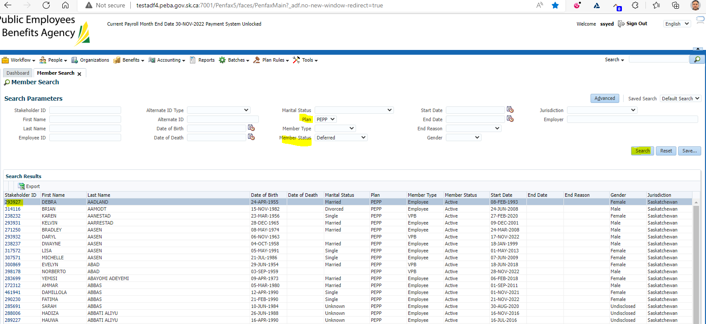

Click on Investments under the Navigation panel

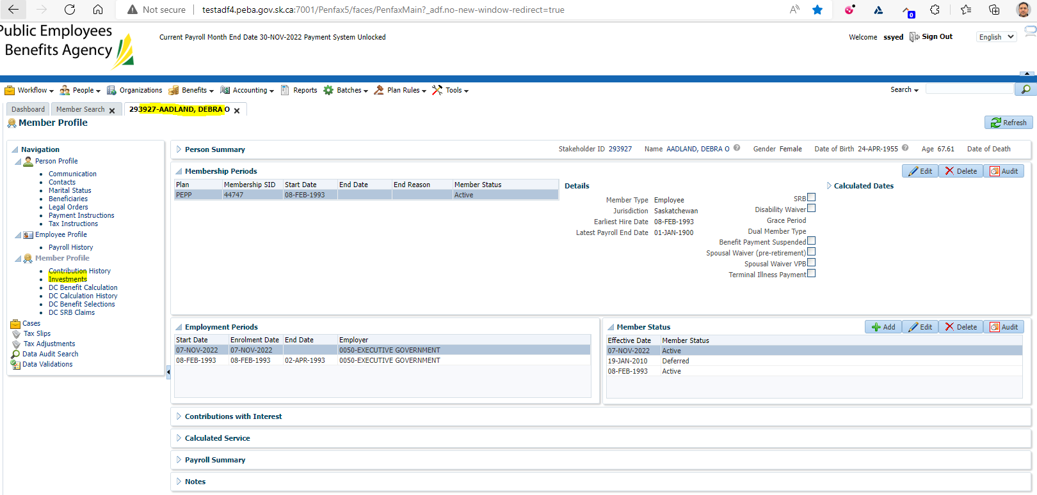

It displays the Current Valuation Date

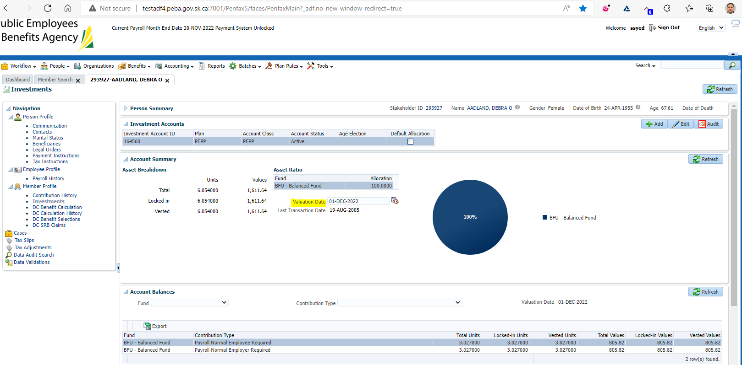

Under account summary change the Valuation date to a date in the past.   
Click the refresh button

This will show the balances in the funds as of the date selected

